Chapter 5

# Try It Yourself: Merge Two Tables

## Excel Instructions

Note: for this exercise, you will need to use .xlsx files, not .csv files. You can download these with the rest of your data sets.

1. Open Customers.xlsx in Excel. 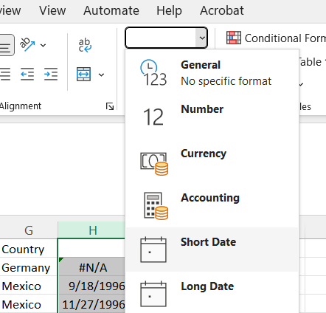
2. Also, open Orders.xlsx in Excel.
3. Ensure OrderDate is sorted in ascending order in **Orders** file (see instructions in “Ch_5_TiY_Order_By_Variable”). We do this because VLOOKUP returns the first found match.
4. What is the first order date in the list from “Antonio Moreno Taquería”?
   1. Start in Customers.xlsx.
   2. Verify the first row of Column C is labeled ContactName.
   3. In Cell H1, type “OrderDate”
   4. Select Column H.
   5. From the Excel ribbon, go to ‘Home’ → ‘Number’ → ‘Short Date’.
   6. In Cell H2, type:

=VLOOKUP(A2,[Orders.xlsx]Sheet1!$B:$D,3,FALSE)

Note: Not all customers have order dates. For this reason, the first Cell H2 will show “#N/A”. Excel can be finicky with copying/pasting. So, we give the logic below to type rather than paste the “=VLOOKUP” command. You can complete it by typing and clicking on the correct cells. VLOOKUP has four parameters, each separated by commas:

* + 1. The first parameter identifies Cell A2 as CustomerID from the **Customers** table.
    2. The second parameter (e.g., “[Orders.xlsx]Sheet1!$B:$D”) identifies Column B in the open Orders.xlsx file as the place to find the CustomerID in the **Orders** table while looking for associated information like OrderDate in Columns B through D.
    3. The third parameter (e.g., “3”) returns the OrderDate as the 3rd column of the range from step (ii) above.
    4. The fourth parameter (e.g., “FALSE”) tells the VLOOKUP function to look for an exact match of the lookup value.
    5. If an exact match is found, VLOOKUP returns the value from the specified column of the range from the specified column of the range.
    6. If no exact match is found, VLOOKUP will return an error (e.g., #N/A).
  1. Click on cell H2 to select it.
  2. Move your cursor to the lower-right corner of cell H2 until it changes to a small black cross (the fill handle).
  3. Double-click the black cross to automatically fill the column. Check the cells to ensure the formula has been correctly copied and automatically adjusted for each row.
  4. You will get “N/A” for some cells (because not all customers have orders now), but most should have dates.
  5. Find the order date by looking at the OrderDate in Row 4 (CustomerID = 3).

1. What is the first order date in the list from “B's Beverages”?
   1. Use the output of #3 to find the order date of “B’s Beverages” in Row 12 (observation 11)